File Browser

Contents

Contents 1

Analysis 1

Problem background 1

Current System 1

Project Outline 1

Techniques used in the current system 3

Objectives 3

General objectives 3

Specific objectives 4

Prospective Users and Acceptable Limitations 4

System limitations 4

# Analysis

## Problem background

After helping a few family members with how to use some features in Windows file explorer, I realised that most people do not use a good portion of the built-in features of the application. Hence if I was able to make a file explorer with a more user-friendly UI and only add the most used features from Window file explorer, essentially making it purely for navigation around the file system of the computer with a few extra bits.

## Current System

The current system is that people use the built-in file browser to the operating system they are running. If Windows they would use File Explorer and Mac users would use Finder. These file browsers are very versatile and have mostly only one problem with them, which is that the everyday person does not use all the features. A feature that infrequently used is network sharing, even being a computer science student, I have never used it. When asking classmates, they said, "Windows file explorer UI not very user-friendly" and "Finder on Mac os is too simple and wish to have move options with moving files around".

## Project Outline

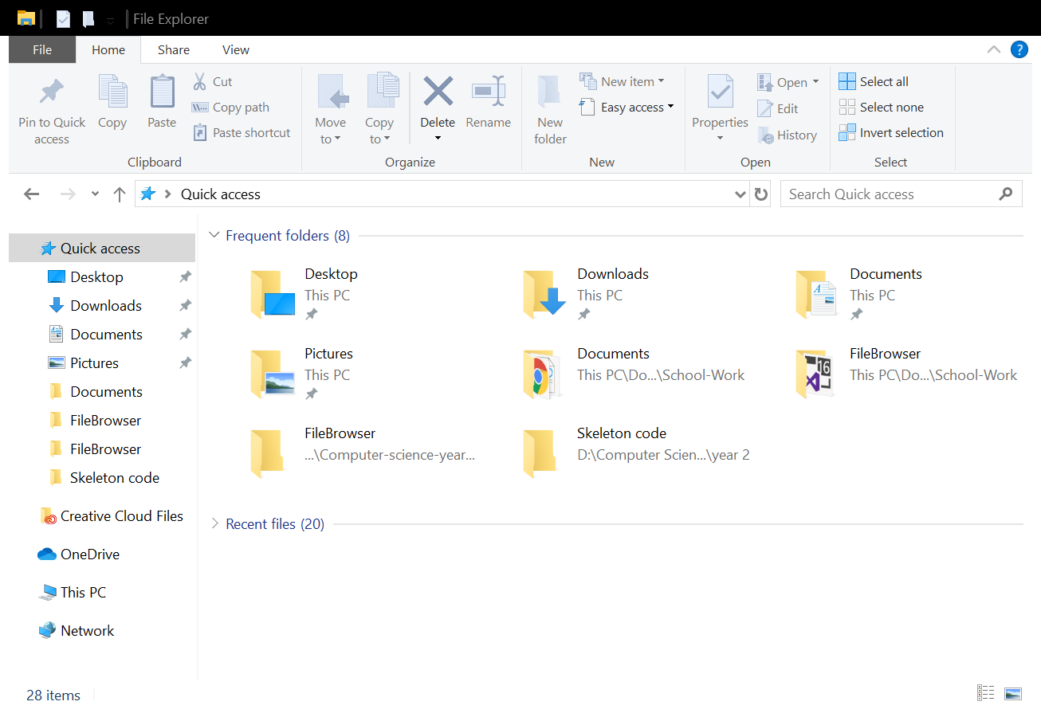

Cluttered Windows File Explorer 1

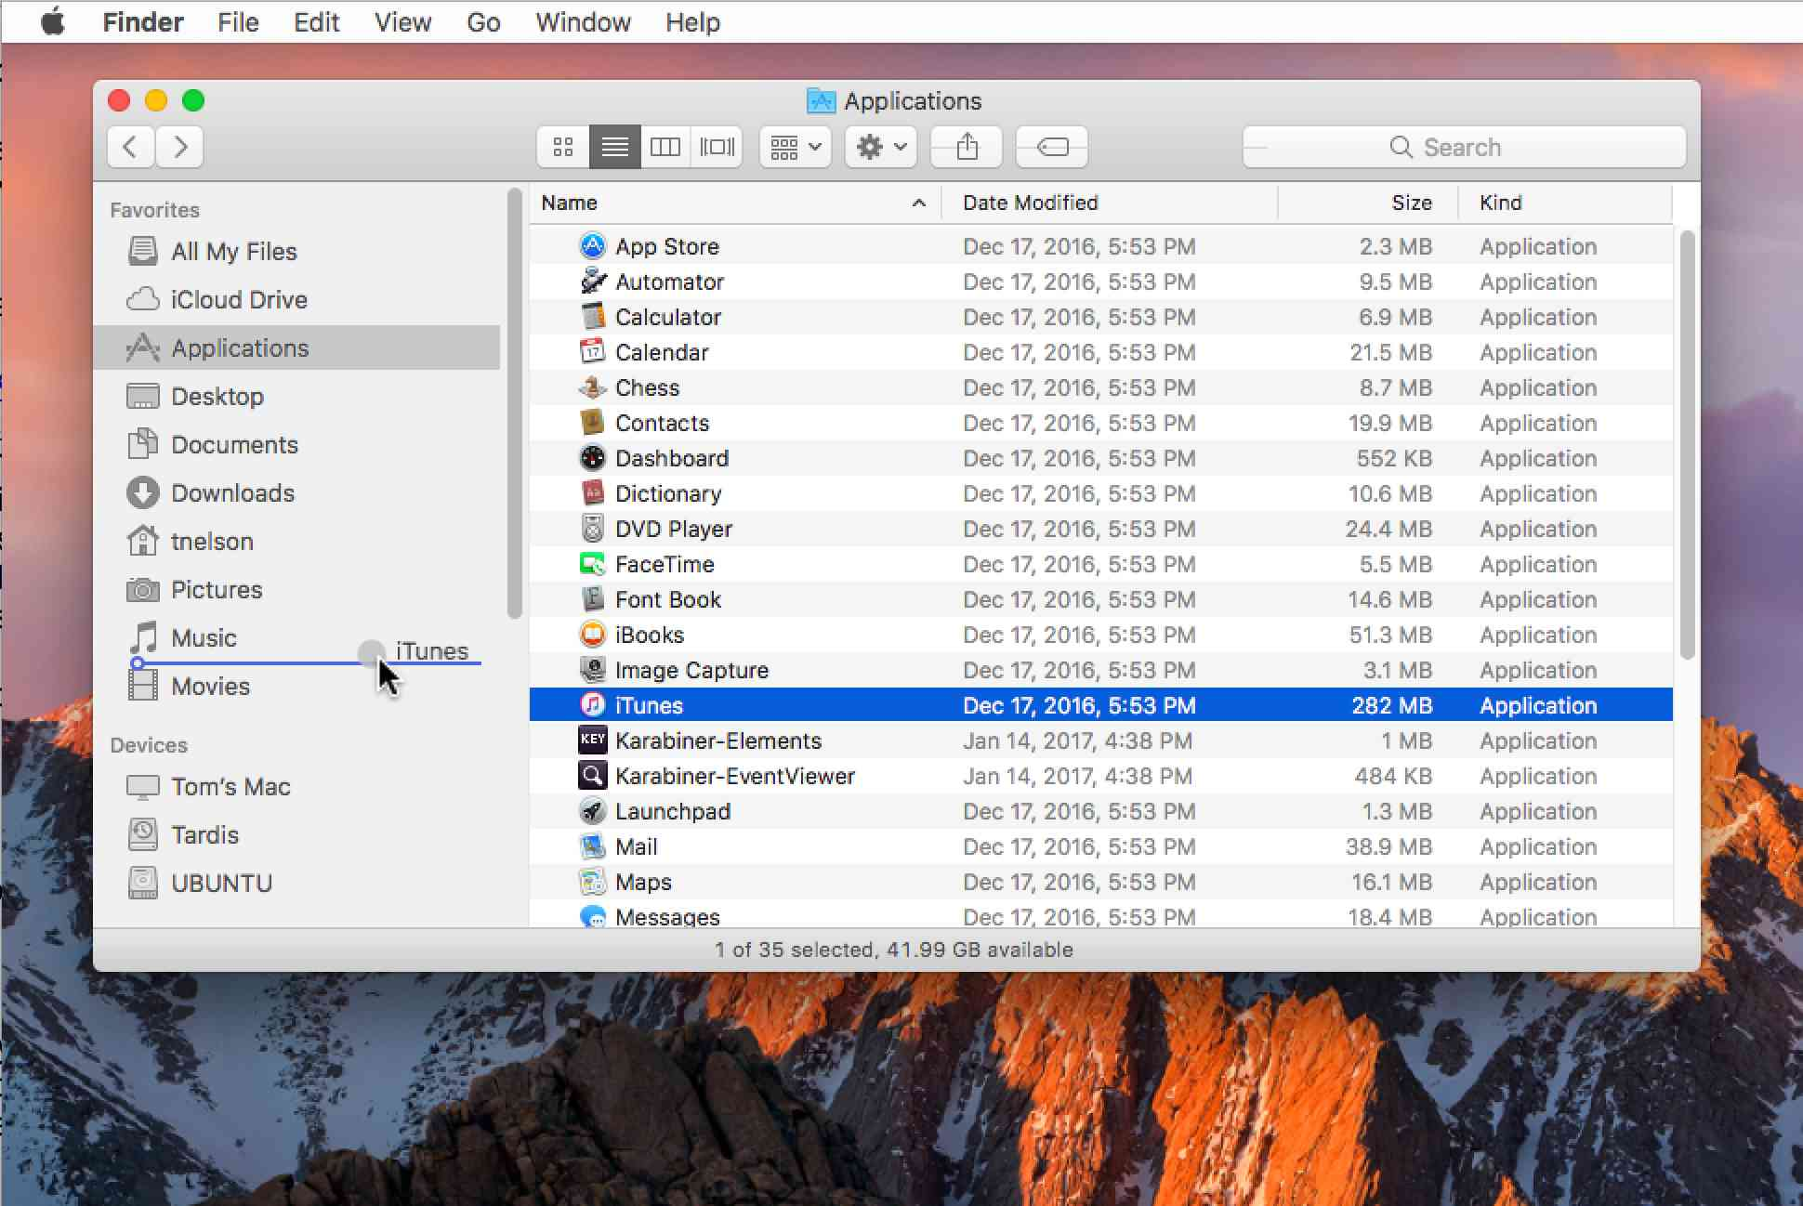

Mac Os Finder 1

## Techniques used in the current system

Current file browsers use an abstract data structure called a tree to hold all of the data. This data structure is very convenient to display a file system, as a folder within another folder already mimics a tree structure. Using a tree structure is essential if the application is to be user-friendly.

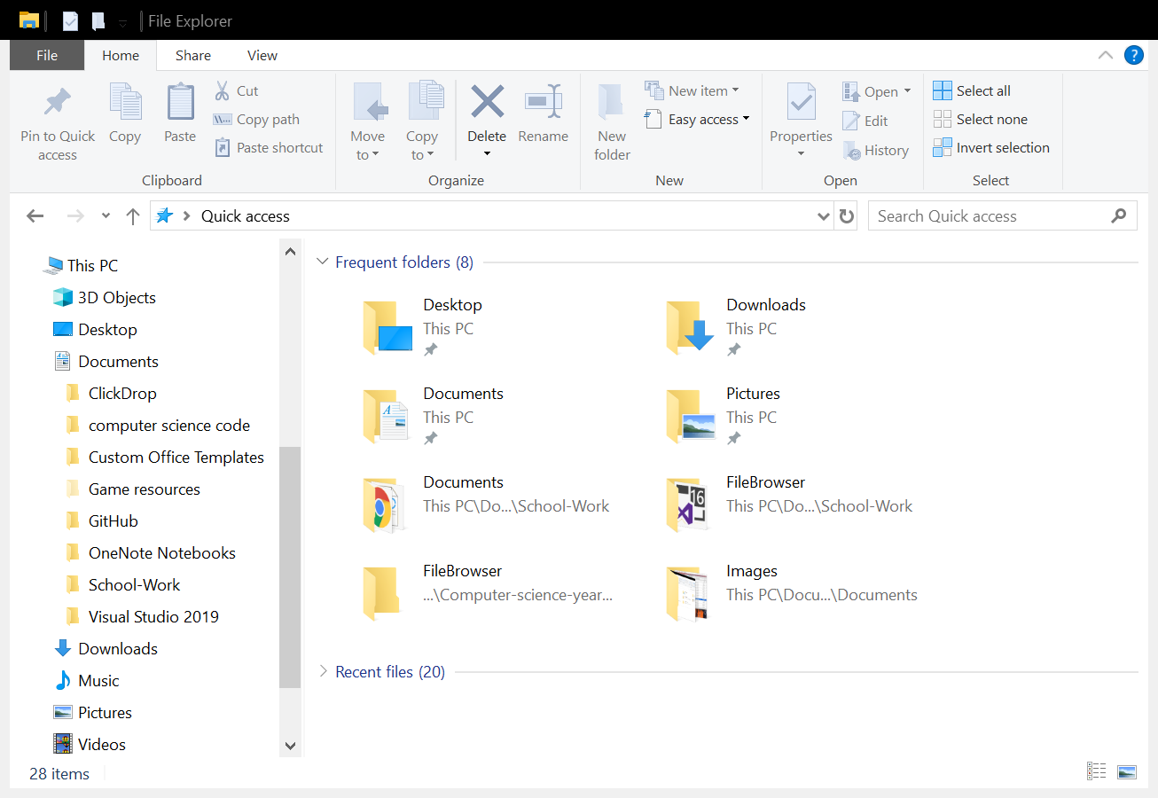 The sidebar in Windows File Explorer is a great example to show the tree data structure.

## Objectives

### General objectives

1. To be run on any computer running the Windows operating system.
2. Have a UI User-friendly.
   * The surface to be uncluttered
   * All fonts should be readable
   * Application wide colour scheme
   * Efficient layout of all of the interactable
3. Give different options on how to move files around.
4. The target audience should understand the application, e.g. no spelling or grammar errors
5. The application should run and be efficient without any freezing
6. Navigation should be comfortable and straight forward
7. To offer an alternative to a file browser then the native built on to the operating system.

### Specific objectives

1. The application should show all files, folder and drives that the user has permission to see.
2. Should have a search bar so the user can search through a directory or the whole computer.
3. Can navigate using both the sidebar and main viewport.
4. Have a forward and back button for navigation.
5. Use a zipper-like structure to hold all of the navigation histories and allow the user to move around using the zipper structure.
6. Have a setting to turn on and off the zipper navigation and other settings.
7. Style the window to have a material theme as it is more of modern design.

## Prospective Users and Acceptable Limitations

The prospective users of the application are going to everyday people who use the Windows operating system. These people are going to need to know general knowledge about computers just to use the programme; the skill level required will be the same as using the built-in file browser.

### System limitations

As this is a project with a limited period for development, the project will have limitations to it. The biggest one being the finishing touches as this will not be industry-standard level as it is only one developer (me) and a small time frame to produce it in. Having a fully bug free application would take longer than the time given, so having minor bugs will be inevitable.

As stated before the application will no be industry-standard, keeping common feature from both Finder and explorer, like moving, deleting or creating files or folders, is needed for the basics of a file browser. Adding a setting for people who have protanomaly, deuteranomaly and tritanomaly colour blindness or having different themes the user can choose might not be achievable due to the time limit. Making complex algorithms for compression and decompression would not be a viable option due to the time limit on the project.

## Data Sources

The data that will populate the application will be the user's files and folders from all of their drives connected to the PC.